* for the trade press * for the trade press * for the trade press * for the trade press *

www.rosenberger.com Fridolfing, July 2019

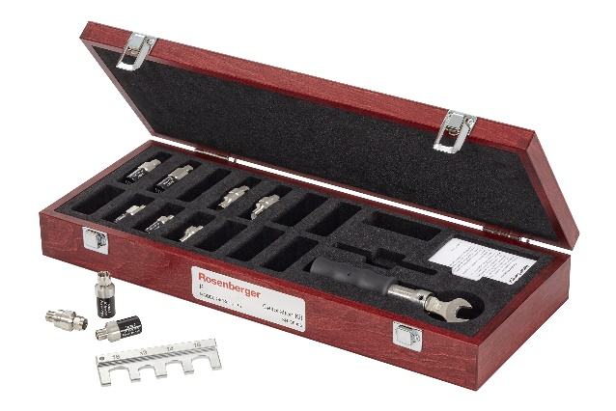
F Interface Calibration Elements up to 6 GHz
Rosenberger has fundamentally revised its product range of F-interface calibration elements. The outstanding improved characteristics are an extended frequency range from DC to 4 GHz up to DC to 6 GHz and doubling mating cycles from 500 to 1000.

The interface standard IEC 61169-24 has been revised due to the distinctively increasing demands in the broadcast television sector. The new 6 GHz-spectrum of Rosenberger consists of calibration adaptors, calibration loads, opens, shorts and loads. A new “full range” calibration adaptor is also available, covers the extremely wide male connector pin tolerance range from 0.64 mm to 1.13 mm and enables adaption of such parts. The new “full range” calibration adapter is also included in the newly composed F calibration kits.

About Rosenberger
Rosenberger Hochfrequenztechnik GmbH & Co. KG was founded in 1958.
Rosenberger, a family owned company, ranks today among the world-wide leading manufacturers of standard and customer-specific connectivity solutions in high frequency, high voltage and fibre optic technology.

The product range covers RF coaxial connectors, RF test & measurement products, RF connectors for automotive electronics, medical and industrial electronics as well as fibre optic products, and cable assemblies. Renowned companies in high-tech industries, e.g. telecommunication, data systems, medical electronics, industrial electronics, test & measurement, aerospace engineering or automotive electronics trust the precision and quality of Rosenberger products.

Rosenberger is certified to IATF 16949:2016, DIN EN 9100, ISO 9001 and ISO 14001.

More than 2,200 people are employed today at the Rosenberger headquarters in Fridolfing/Tittmoning (Upper Bavaria, Germany). Worldwide, the Rosenberger group operates manufacturing and assembly locations as well as Rosenberger sales offices in Europe, Asia and North and South America where – in total – approx. 11,000 employees develop, produce and sell our products.

Contact:
Fritz Herrmann
Marketing Services

Phone +49 (0)8684 18-1263
e-mail: fritz.herrmann@rosenberger.com

